Ahmad Barakat
ITEC 420
Nayana Pampapura
Module 1: Install Windows Server

By following the instructions in the assignment steps, I was able to download and install VirtualBox, creating a new virtual machine within VirtualBox, and adding the Windows Server 2016 ISO, that way the VM will boot from the ISO. After Windows installs and reboots a few times, I set up a password and login, that way I could run Windows Server 2016 on VirtualBox.
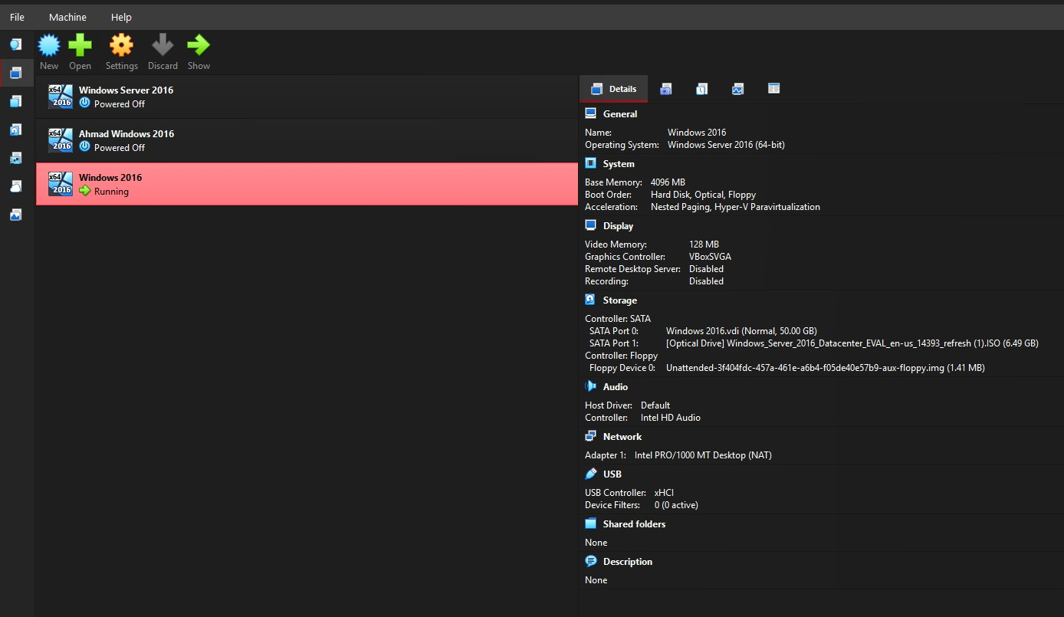
This is a screenshot of VirtualBox’s successful download, and you can see that the new “Windows 2016” server that I created is in fact running.

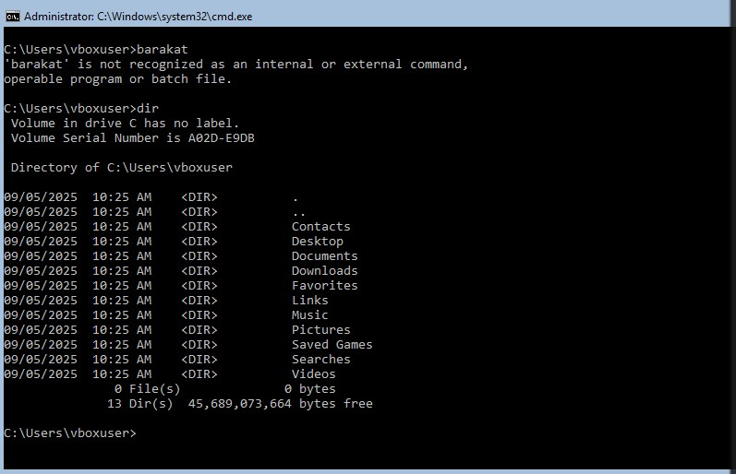

With this screenshot, I have used the “dir” command to show a directory within the Windows 2016, this proves that it is installed within the system in VirtualBox.

